## ****SOFTWARE REQUIREMENTS SPECIFICATION (SRS) DOCUMENT****

**FOR DISASTER MANAGEMENT SYSTEM APP**

Table of Contents

SOFTWARE REQUIREMENTS SPECIFICATION (SRS) DOCUMENT 1

1.2 Scope 2

1.3 Definitions 3

**2**. OVERALL DESCRIPTION 4

2.1 Product Perspective 4

2.2 User Classes 4

2.3 Assumptions and Dependencies 4

3. Functional Requirements 4

4. Non-Functional Requirements 5

5. System Architecture 6

6. Data Flow Diagram (Level 1) Here's a textual description of the Level 1 DFD 6

**1.** INTRODUCTION

#### 1.1 Purpose

This document outlines the requirements for a mobile/web-based Disaster Management System that enables early warning, real-time alerts, victim reporting, emergency response coordination, and data management for disasters such as floods, fire outbreaks, earthquakes, landslides, and others so as to help prevent disaster from affecting Users.

# 1.2 Scope

**Allow Users to Report Disasters**

**Explanation:**  
Users can report incidents they witness or experience, such as floods, fires, earthquakes, or landslides. This includes:

* Selecting the type of disaster
* Pinpointing the location (via GPS or map)
* Uploading images, videos, or descriptions
* Submitting the report in real time
* Being able to submit I local or Native language.

**Purpose:**  
To collect ground-level data quickly, helping authorities verify and act promptly.

**Provide Alerts and Early Warnings**

**Explanation:**  
The app will push notifications to users about impending or ongoing disasters using in that particular area or location or town:

* Weather and geological data (from integrated APIs or sensors)
* Admin-triggered alerts based on verified reports

Purpose**:**  
To reduce casualties by informing people early and guiding them on what to do (e.g., evacuate, stay indoors).

**Enable Government and Emergency Services to Coordinate Responses**

**Explanation:**  
Admins and first responders will:

* Access a dashboard showing all reports and locations
* Assign response units (fire, ambulance, police)
* Track the status of ongoing disasters

**Purpose:**  
To streamline response times, allocate resources efficiently, and communicate internally.

**Display Affected Areas on Maps Stating the Type of Disaster Occurring**

**Explanation:**  
Interactive maps will show for the particular area suffering from that disaster:

* Real-time disaster zones (heatmaps or icons)
* Type of disaster (color-coded)
* Verified vs. unverified reports

**Purpose:**  
To give users and responders visual insights into what’s happening, where, and how severe it is.

**Provide Emergency Contacts and Safety Tips**

**Explanation:**  
Static pages and pop-ups will offer:

Hotline numbers (fire service, police, hospitals, shelters)

Safety measures for each disaster type (before, during, after)

**Purpose:**  
To empower users with immediate help and self-protection steps during critical moments.

**Maintain a Disaster History Database for Analysis**

**Explanation:**  
All reports, responses, and outcomes will be stored with:

* Date/time stamps
* Location
* Type of disaster
* Response taken

**Purpose:**  
For future planning, government policy, academic research, and to identify high-risk areas and response gaps.

# 1.3 Definitions

**User**: Citizen or resident using the app.

**Admin**: Authorized personnel managing data and alerts.

**First Responders**: Firefighters, police, medics, NGO’s Community service (Community helep) etc.

**Disaster**: Natural or human-made emergency (e.g., earthquake, flood).

# **2. OVERALL DESCRIPTION**

# 2.1 Product Perspective

The app will function as a centralized platform accessible via mobile and web, with backend support for data management and integration with notification systems and the availability of sensors for most disasters.

# 2.2 User Classes

**General Users**: Receive alerts, report incidents.

**Admin/Disaster Management Authority**: Manage events, verify reports via available google maps on the systems.

**First Responders**: View locations and take action.

# 2.3 Assumptions and Dependencies

Internet/GPS access is available.

Users have Android or iOS devices.

Government and emergency agencies cooperate.

# **3. Functional Requirements**

**FR1: User Registration/Login**

Users must be able to register and log in using email or phone number.

**FR2: Real-Time Alerts**

Users receive alerts based on location and disaster type in particular area.

**FR3: Report Disaster**

Users can submit reports including photos, video, location, and type of disaster.

**FR4: Admin Dashboard**

Admins can view reports, approve or verify incidents, and push alerts.

#### FR5: First Responder Interface

Displays verified incidents with directions.

#### FR6: Emergency Contacts and Safety Tips

Static pages with emergency numbers and disaster safety info.

#### FR7: Map Integration

Displays disaster zones and reported incidents.

#### FR8: Disaster History Logs

Store and retrieve previous incidents with date, time, and location.

**FR9:** **Community Helep**

Request community help

# **4. Non-Functional Requirements**

#### NFR1: Performance

Must support at least 10,000 concurrent users.

#### NFR2: Security

Data must be encrypted and user authentication is required.

#### NFR3: Availability

99.5% uptime with support for cloud hosting and backups.

#### NFR4: Usability

Intuitive UI/UX with accessibility support.

#### NFR5: Scalability

Ability to scale up to multiple regions and disaster types.

# **5. System Architecture**

**Frontend**: React (Web), React Native (Mobile)

**Backend**: Node.js/Express or Django

**Database**: MySQL/PostgreSQL

**Notification Service**: Firebase Cloud Messaging (FCM)

**Map API**: Google Maps or OpenStreetMap

# **6**. Data Flow Diagram (Level 1) Here's a textual description of the Level 1 DFD

**Processes:**

**User Management**

Register/Login

Profile info

**Disaster Reporting**

Input: Disaster type, location, media

Output: Report entry in database

**Alert Distribution**

Input: Disaster data

Output: Push notifications, map updates

**Admin Actions**

Verify report

Send mass alerts

**Response Coordination**

Notify first responders

Update status logs

**Data Stores:**

User Database

Disaster Reports

Verified Disasters

Response Logs

Safety Info

**External Entities:**

Users

Admin

First Responders

Notification Services (e.g., FCM)

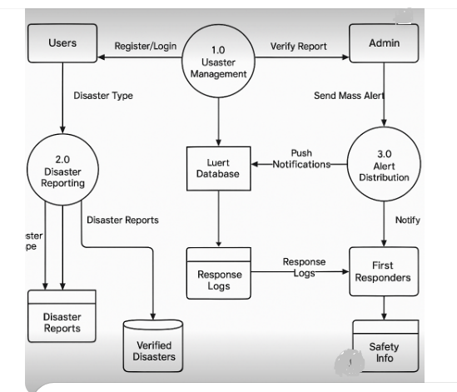

窗体顶端

窗体底端